Name : BOMMANAPALLI SATEESH
Hall ticket no: 2403a51436
Batch : 17

Question 1:
Prompt Engineering Zero-shot (Scenario)
Your product manager asks for a zero-shot prompt that generates Python code to find the
lowest-priced item from a price list.
(Include docstrings + comments + tests for the resulting code.

Prompt :
Write Python code that finds the lowest-priced item from a dict of {name: price}.
Include:
- A function `find_lowest_price(items)` with docstrings and comments.
- Input validation (raise ValueError if empty).
- A __main__ block with tests (multiple items, tie case, empty input).
Code :
def find_lowest_price(items):
"""
Find the lowest-priced item from a dictionary of {name: price}.

Args:
items (dict): A dictionary with item names as keys and prices as values.

Returns:
tuple: A tuple of (item_name, price) for the lowest-priced item.

Raises:
ValueError: If the dictionary is empty.
"""
# Input validation: check if the dictionary is empty
if not items:
raise ValueError("Dictionary cannot be empty")

# Find the item with the minimum price using min()
# min() with key=lambda item: item[1] compares by price (second element of tuple)
lowest_item = min(items.items(), key=lambda item: item[1])

return lowest_item

if __name__ == "__main__":
# Test 1: Multiple items - should return the lowest-priced item
print("Test 1: Multiple items")
items1 = {"apple": 1.5, "banana": 0.8, "orange": 1.2, "grape": 2.0}
result1 = find_lowest_price(items1)
print(f" Items: {items1}")
print(f" Lowest: {result1}")
assert result1 == ("banana", 0.8), "Failed: Expected ('banana', 0.8)"
print(" ✓ Passed\n")

# Test 2: Tie case - multiple items with the same lowest price
print("Test 2: Tie case (same lowest price)")
items2 = {"item_a": 5.0, "item_b": 5.0, "item_c": 10.0}
result2 = find_lowest_price(items2)
print(f" Items: {items2}")
print(f" Lowest: {result2}")
# min() returns the first item encountered with the minimum price
assert result2[1] == 5.0, "Failed: Expected price of 5.0"
print(" ✓ Passed\n")

# Test 3: Empty input - should raise ValueError
print("Test 3: Empty input")
items3 = {}
try:
result3 = find_lowest_price(items3)
print(" ✗ Failed: Expected ValueError to be raised")
except ValueError as e:
print(f" Caught expected error: {e}")
print(" ✓ Passed\n")

# Test 4: Single item
print("Test 4: Single item")
items4 = {"only_item": 99.99}
result4 = find_lowest_price(items4)
print(f" Items: {items4}")
print(f" Lowest: {result4}")
assert result4 == ("only_item", 99.99), "Failed: Expected ('only_item', 99.99)"
print(" ✓ Passed\n")

print("All tests passed!")

output :
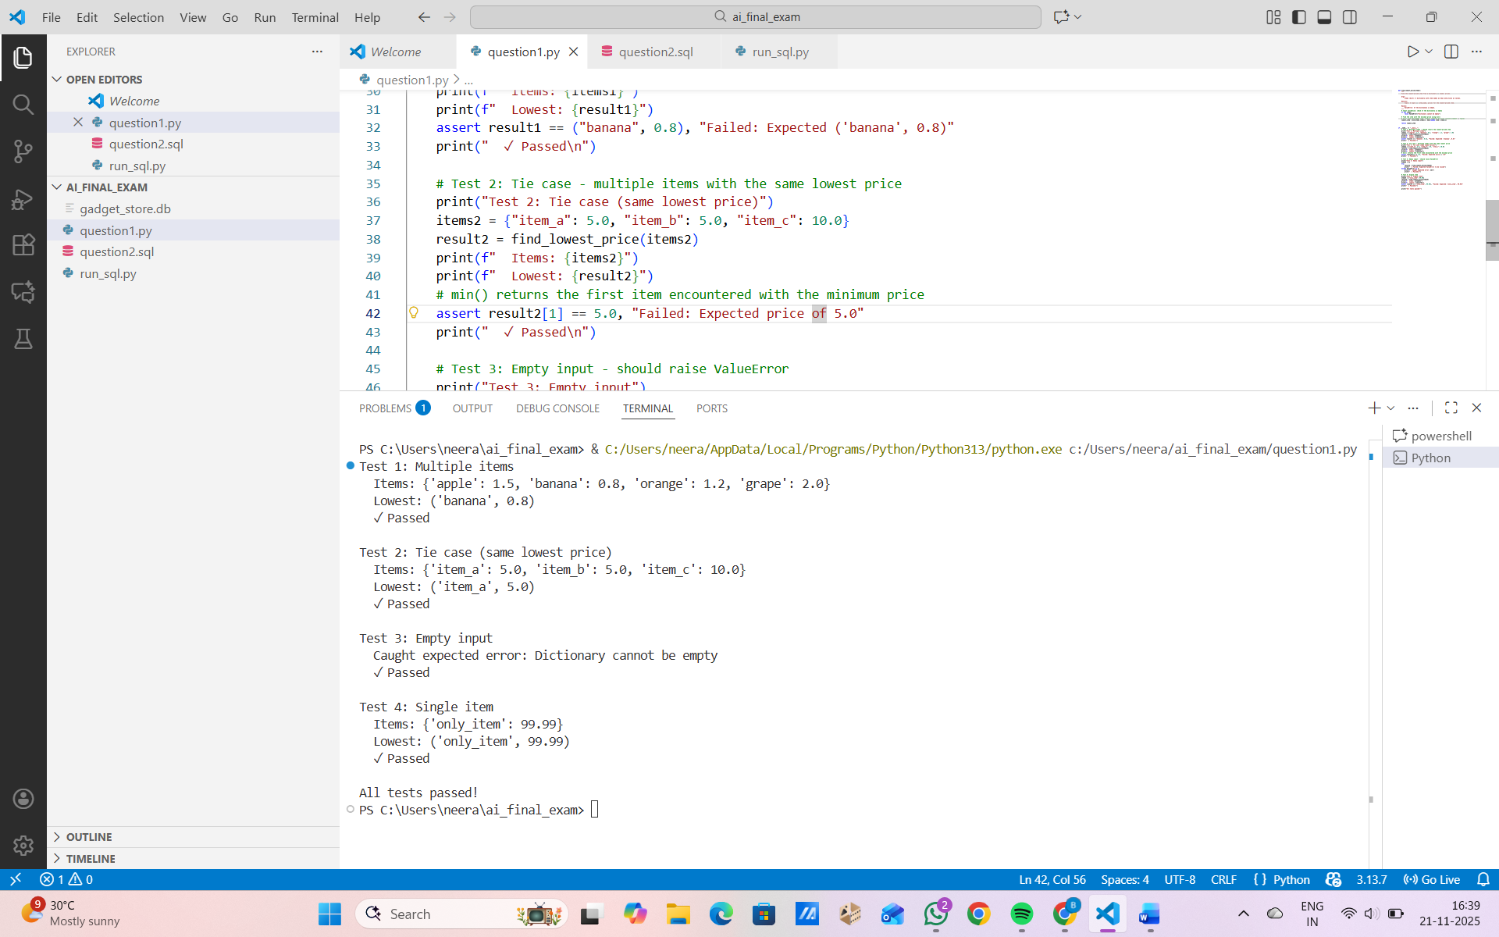

Question 2:
Create SQL for an online gadget store with tables: Brands, Gadgets, Sales.
Include sample test data.
Add commented queries to:
- fetch top-selling gadgets,
- add a new brand,
- update gadget inventory.
Output only SQL.

Prompt :
An online gadget store requires database tables for:
• Gadgets
• Brands
• Sales
Generate SQL queries to:
• fetch top-selling gadgets
• add a new brand
• update inventory

Code :
-- Online Gadget Store Database Schema

-- Create Brands table
CREATE TABLE Brands (
BrandID INTEGER PRIMARY KEY AUTOINCREMENT,
BrandName VARCHAR(100) NOT NULL UNIQUE,
Country VARCHAR(50),
FoundedYear INTEGER
);

-- Create Gadgets table
CREATE TABLE Gadgets (
GadgetID INTEGER PRIMARY KEY AUTOINCREMENT,
GadgetName VARCHAR(100) NOT NULL,
BrandID INTEGER NOT NULL,
Price DECIMAL(10, 2) NOT NULL,
Inventory INTEGER NOT NULL DEFAULT 0,
Category VARCHAR(50),
FOREIGN KEY (BrandID) REFERENCES Brands(BrandID)
);

-- Create Sales table
CREATE TABLE Sales (
SaleID INTEGER PRIMARY KEY AUTOINCREMENT,
GadgetID INTEGER NOT NULL,
QuantitySold INTEGER NOT NULL,
SaleDate DATE NOT NULL,
TotalAmount DECIMAL(12, 2) NOT NULL,
FOREIGN KEY (GadgetID) REFERENCES Gadgets(GadgetID)
);

-- Insert sample test data into Brands
INSERT INTO Brands (BrandName, Country, FoundedYear) VALUES
('Apple', 'USA', 1976),
('Samsung', 'South Korea', 1938),
('Sony', 'Japan', 1946),
('Microsoft', 'USA', 1975),
('LG', 'South Korea', 1947);

-- Insert sample test data into Gadgets
INSERT INTO Gadgets (GadgetName, BrandID, Price, Inventory, Category) VALUES
('iPhone 15', 1, 999.99, 150, 'Smartphone'),
('iPad Air', 1, 599.99, 80, 'Tablet'),
('Galaxy S24', 2, 899.99, 200, 'Smartphone'),
('Galaxy Tab S9', 2, 549.99, 120, 'Tablet'),
('PlayStation 5', 3, 499.99, 50, 'Gaming Console'),
('WH-1000XM5', 3, 399.99, 75, 'Headphones'),
('Surface Laptop 6', 4, 1299.99, 60, 'Laptop'),
('OLED TV 55"', 5, 1499.99, 25, 'Television'),
('Galaxy Watch 6', 2, 299.99, 100, 'Smartwatch'),
('AirPods Pro', 1, 249.99, 200, 'Headphones');

-- Insert sample test data into Sales
INSERT INTO Sales (GadgetID, QuantitySold, SaleDate, TotalAmount) VALUES
(1, 5, '2025-11-15', 4999.95),
(3, 8, '2025-11-14', 7199.92),
(2, 3, '2025-11-13', 1799.97),
(5, 2, '2025-11-15', 999.98),
(6, 4, '2025-11-12', 1599.96),
(7, 1, '2025-11-15', 1299.99),
(4, 6, '2025-11-11', 3299.94),
(8, 1, '2025-11-14', 1499.99),
(9, 10, '2025-11-15', 2999.90),
(10, 7, '2025-11-13', 1749.93);

-- QUERY 1: Fetch top-selling gadgets (by quantity sold and total revenue)
-- Returns gadget name, brand name, total quantity sold, and total revenue
-- SELECT
-- g.GadgetName,
-- b.BrandName,
-- SUM(s.QuantitySold) AS TotalQuantitySold,
-- SUM(s.TotalAmount) AS TotalRevenue
-- FROM Sales s
-- JOIN Gadgets g ON s.GadgetID = g.GadgetID
-- JOIN Brands b ON g.BrandID = b.BrandID
-- GROUP BY s.GadgetID, g.GadgetName, b.BrandName
-- ORDER BY TotalQuantitySold DESC, TotalRevenue DESC
-- LIMIT 10;

-- QUERY 2: Add a new brand to the database
-- Example: Adding a new technology brand
-- INSERT INTO Brands (BrandName, Country, FoundedYear)
-- VALUES ('Google', 'USA', 1998);

-- QUERY 3: Update gadget inventory after a sale
-- Example: Decrease iPhone 15 inventory by 5 units
-- UPDATE Gadgets
-- SET Inventory = Inventory - 5
-- WHERE GadgetID = 1;

-- Alternative inventory update: Set specific inventory level
-- UPDATE Gadgets
-- SET Inventory = 100
-- WHERE GadgetName = 'iPhone 15';

Output :
